Outputs
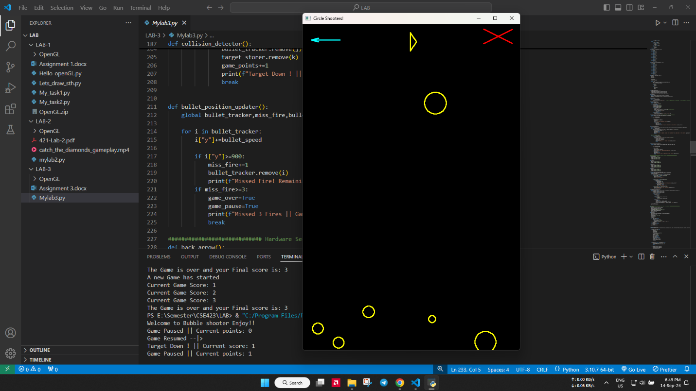

Code:
https://colab.research.google.com/drive/1yLvcAM-pxrtkqmzxclhrsFoQUoHGSDb4?usp=sharing

